Universal Carton Label Specification:
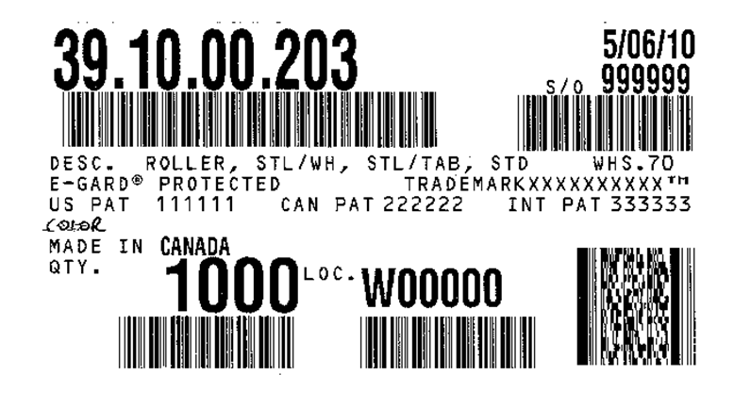
1
2
3
4
5
6
7
8
9
COLOR: COPPERTONE METALLIC DDDDDeDEDDescritpionOLOR
10
11
12
13
14
- Image above is a mocked up sample identifying all fields possible. Depending on the specific Item Number, certain fields may be omitted per logic below. Sizes can be scaled from this image.

- Printed on standard Direct Thermal, white label stock with adhesive backing and measuring 2-1/2” x 5” with rounded corners.

- Line Description:

- Item Number
- Item Number Bar Code, format: 3 of 9
- Description – per Truth Item Master record
- Color Description– per Item Master record of Color Code and TRCOLOR description file
  - If Color Code is null or if “00”, this line will not print
- Protection Trademark per Item Master record
  - If no protection, this line will not print
- Patent Numbers per Item Master record
  - If no patents, this line will not print
- Country of Origin per Facility Master record
  - If Country of Origin is null, this line will not print
- Carton Quantity per Facility Master record as default
  - Default can be over ridden by user
- Carton Quantity Bar Code, format: 3 of 9
- Date of Manufacture
  - Correlates to date label is printed
- Shop Order or Purchase Order Number
  - “P/O” is indicated if Purchase Order
  - “S/O” is indicated if Shop Order
- Shop Order or Purchase Order Bar Code, format: 3 of 9
- Facility Code attached to Shop Order or Purchase Order
- Product Trademark per Item Master record
  - Registered or Applied markings trail the Product Trademark
  - If Product Trademark is null, this line will not print

